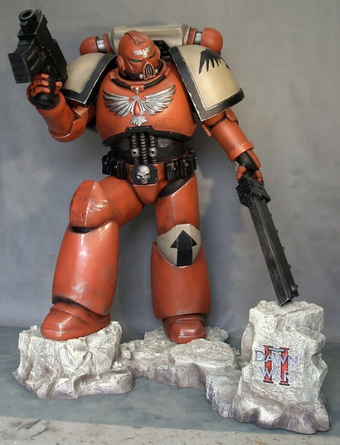

**THE RESTLESS BOLTERS**

* Bruce Manirath [s3805194@student.rmit.edu.au](mailto:s3805194@student.rmit.edu.au)
* Jaryd Cavanagh [JCav27@outlook.com](mailto:JCav27@outlook.com)
* Jennelle Roberts [s3788427@student.rmit.edu.au](mailto:s3788427@student.rmit.edu.au)
* Jack Marsden [s3803381@student.rmit.edu.au](mailto:s3803381@student.rmit.edu.au)
* Kyle Francis [s3805196@student.rmit.edu.au](mailto:s3805196@student.rmit.edu.au)

*Github Link:*

*Github Repository:* <https://github.com/s3805194/Restless-Bolters>

|  |
| --- |
| **GROUP MEMBERS** |

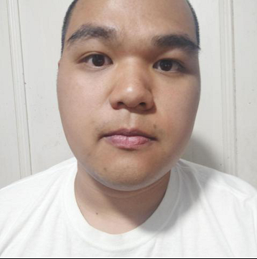Bruce is from Western Sydney and has a goal of getting into Software Development and is interested in AI and Automation.

He is a music buff that loves to play Bass Guitar and has an affinity for cats. He has an interest about how people and governments are going to adapt to the increased use of AI and automation. Geopolitics is an interest for both Jennelle and Bruce and AI and automation brings up some interesting questions in this perspective. These questions fascinate Bruce and Jennelle.

Questions like, “Who owns the data from facial recognition programs?”, “Can facial recognition surveillance contravene the right to privacy?”, “Who sets the ethics that Self Driving Cars use to make decisions?”, “Is there any way to regulate the use of data and police these regulations?”, “How do we protect ourselves from unsavory Governments that ignore International Conventions on privacy and data collection?”

**NEED BRUCE IT EXPERIENCE**

Jennelle is also originally from Western Sydney, but now living in Melbourne. The second child of 5, Jennelle is used to noise, differing opinions and nerds. The whole family are nerds made up of Scientists, Psychologists and IT Professionals.

Jennelle has a 9 year old daughter who is Autistic. So Jennelle is always up for a chat about diversity advocacy, neurodivergence acceptance and aliens. Aliens are a big topic at the Roberts house.

Jennelle loves to make things fit into lists and tables and as she continued through her career, she realised that this way of organising things meant that Data was something right up her alley. She currently works as a Data Analyst for a Volume Residential builder focusing on Material Data.

Jaryd is AWOL.

Jack is AWOL

Kyle is AWOL

|  |
| --- |
| **PERSONALITY PROFILING** |

Team members had an assignment that required each member to do a Myers Briggs tests.

The results were:

Bruce **INTP (Introversion, Intuition, Thinking, Perceiving)**

Jennelle **ISTJ (Introversion, Sensing, Thinking, Judgment)**

Jaryd **AWOL**

**Jack INTJ (Introversion, Intuition, Thinking, Judgment)**

**Kyle AWOL**

According to the Myers Briggs results, it seems that Restless Bolters members are a collection of Introverts.

We do not like to be front facing and often prefer quiet reflection and privacy. We process ideas and concepts thoroughly by ourselves before taking it out to be used/evaluated by someone else.

We are also Thinkers that prefer objective truths and a process of elimination to determine outcomes.

Where we differ is between Sensing/Intuition and Judgement/Perceiving.

Sensing people need concrete and tangible ideas and deal with the current presented situation, whereas Intuition people place an emphasis on meaning and associations and are very good at spotting patterns.

Judgement people are structured and postulate theories about the world, always willing to try new information in their structured understanding. Whereas Perceiving people are more unstructured and like to keep their options open. But this also means that they are more open to change as they do not have an existing structure.

One of the other tests that Bruce completed was The Vark Questionnaire where he was assessed as a Mild read/write learning type. People with this Vark Assessment prefer to write and read, use lists, extract meanings from headings and titles and like to have clarity in what is written.

The last test that Bruce completed was the Big Five Personality test. His result (Openness, Conscientiousness, Extraversion, Agreeableness, Neuroticism) had a contradiction with his Myers Briggs result. Myers Briggs assessed him as Introverted, but the Personality Test assessed him as Extroverted.

One of the other tests that Jennelle completed was an Online Learning Style Test. Her results were 60% Auditory, 30% Visual and 10% tactile. This indicates that Jennelle learns by listening and store information the way that it sounds.

The last test that Jennelle completed was the Verbal Reasoning Test. This test was a high result (8 out of 10) for Jennelle’s ability to quickly go through presented verbal data, identify the issues and reach logical conclusions.

JARYD IS AWOL

|  |
| --- |
| **IDEAL JOBS COMPARISON** |

From the assessment: Compare everyone’s ideal jobs. What common elements are there, if any? What differentiates each position from the others, if anything? How similar or different are your career plans across the group?

|  |
| --- |
| **INDUSTRY DATA** |

From the assessment: What are the Job Titles for your group's ideal jobs? How do each of these rank in terms of demand from employers?

Ideal jobs skill set:

How do the IT-specific skills in your required skill set rank in terms of demand from employers?

o How do the general skills in your required skill set rank in terms of demand from employers?

o What are the three highest ranked IT-specific skills which are not in your required skill set?

o What are the three highest ranked general skills which are not in your required skill set?

**BRUCE/JENNELLE/JARYD to personally answer; Having looked at the Burning Glass data, has your opinion of your ideal job changed? Why or why not?**

|  |
| --- |
| **IT WORK** |

**Interview an IT Professional**

|  |
| --- |
| **IT TECHNOLOGIES** |

**REPORT ON 4 TECHNOLOGIES**

What does it do? (600 words) What is the state of the art of this new technology? What can be done now? What is likely to be able to do be done soon (say in the next 3 years)? What technological or other developments make this possible?

What is the likely impact? (300 words) What is the potential impact of this development? What is likely to change? Which people will be most affected and how? Will this create, replace or make redundant any current jobs or technologies?

How will this affect you? (300 words) In your daily life, how will this affect you? What will be

|  |
| --- |
| **PROJECT IDEA** |

|  |
| --- |
| **FEEDBACK** |

**SPARKPLUS**

Towards the end of the assignment period, you should reflect as a group on how well you think you have performed in this assignment. You should include whatever evidence you may have about the groups processes (such as commit trails from GitHub, or project meeting minutes). Each member of the group should contribute up to 200 words about their own perception of the group, and the group as a whole should contribute around 400 words. This should include the following attributes.

• What went well

• What could be improved

• At least one thing that was surprising

• At least one thing that you have learned about groups

• Remember to include in your section on Tools how well you think your Github log of activity reflects your group’s work on this assignment.